Sophia Fox
[Company name]
[Date]
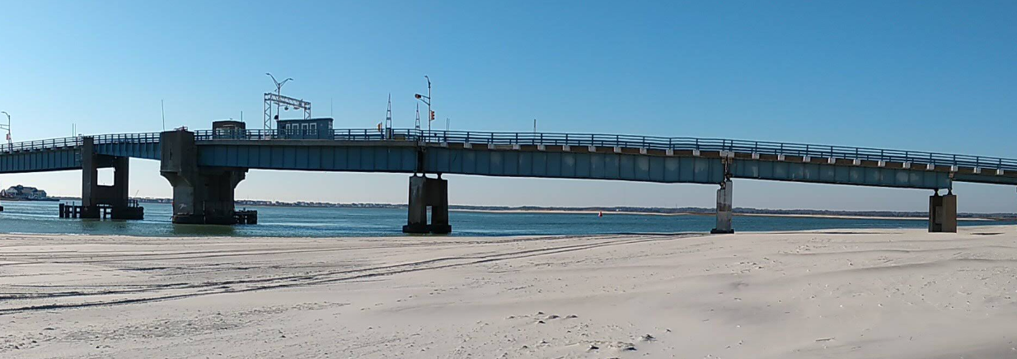

CREATED BY:

Stokes Creative Group, Inc.

May 2026

TOWNSENDS INLET BRIDGE LCD

CAPE MAY COUNTY
AVALON & SEA ISLE CITY, NJ

CONCEPT DEVELOPMENT (CD) PHASE

PUBLIC INVOLVEMENT ACTION PLAN
tABLE OF Contents
1. Project Overview 2
2. Purpose of the Public Involvement Action Plan 2
3. Public Involvement Action Plan Development 2
4. Community Outreach 3
4.1 Stakeholder Coordination 3
4.2 Local Officials Briefings (LOB) 3
4.3 Stakeholder Meetings 3
4.4 Public Information Center (PIC) 3
5. Content Development 4
5.1 Project Website 4
5.2 Project Fact Sheet 4
6. Public Outreach Summary 4
7. Public Outreach Schedule ………………………………………………………………………………………………………………….. 4

1. Project Overview
The Townsends Inlet Bridge was built in 1939 and is nearing the end of its service life. The bridge has been rehabilitated several times in the past 10-15 years; and most recently Spans 1 through 7 were replaced in July 2019. The most current Bridge Re-Evaluation Report indicates that the bridge is in overall poor condition, due to the poor condition of its superstructure and substructure and low inventory ratings. In order to replace the bridge or perform a major rehabilitation using federal or state funding, a Local Concept Development (LCD) Study must first be completed to gain project input from public officials, stakeholders, and the general public. The LCD process will develop a Purpose and Need Statement and establish project goals and objectives to help examine conceptual alternatives.

As the bridge serves many varied interests, the LCD Study process is designed to enable full public participation. Conceptual plans for the rehabilitation or replacement of the Townsends Inlet Bridge will be presented to the public so that the community’s voices are heard.

2. Purpose of the Public Involvement Action Plan
The Public Involvement Action Plan (PIAP) is a framework to accomplish open, proactive, and productive community and stakeholder discussions concerning the Townsends Inlet Bridge LCD Study. Strategies and audiences identified during this phase for public involvement may be incorporated into future outreach efforts.
This plan serves as the foundation for public outreach. It considers the varying communication needs of elected and local officials, residents, businesses, resource agencies and personnel, and other stakeholders and special interest groups in the project area. Communication with local officials, stakeholders, travelers on all modes, and community members will be undertaken to inform and share information on its progress. Through this process, messages and deliverables will be matched with their appropriate audiences to ensure that information being shared is pertinent to their concerns and constituents.

3. Public Involvement Action Plan Development
The PIAP describes the comprehensive effort to advance community awareness and participation and to promote inclusivity to be performed during this Concept Development (CD) phase. The document outlines the Project Team, project elements, and the proposed communication methods recommended for the CD phase. This is a living document and will be modified and amended as necessary, as the phase progresses.
All public involvement activities will adhere to current federal transportation legislation.

The PIAP includes the following elements:
- Community Outreach
- Content Development
- Public Outreach Summary

4. Community Outreach

4.1 Stakeholder Coordination
Stokes will update the stakeholder list developed in April 2025. The list organizes stakeholder contact information including name, address, affiliation, and email, and it will be utilized to send project-related information and invitations to meetings.
Interested and affected stakeholders on the list include:

- Avalon and Sea Isle City
  - Elected Officials
  - Office of Emergency Services
  - Engineers and Planners
  - Business Groups
  - Local School Districts
  - Neighborhood Associations
  - Civic and Cultural Groups
  - Environmental Organizations

- Cape May County
  - County Commissioners
  - Elected Officials
  - Cape May County Bridge Commission
  - Department of Engineering
  - Department of Public Works
  - Emergency Response Officials
- Private residential property owners within 200 ft. of the bridge.
- Local Businesses and Landmarks

4.2 Local Officials Briefings (LOB)
To facilitate a convenient exchange with local officials, it is anticipated that two in-person LOBs will be held during the LCD phase, one with Avalon and Sea Isle City, and the second with Cape May Court House. Elected officials, engineers, planners, municipal councils, county commissioners and school district officials will be invited to these events. Each briefing will provide officials with the latest information regarding the project status and provide an opportunity for feedback on the conceptual alternatives developed for the project, prior to presenting the information to the public. Follow-up briefings will be held to obtain concurrence for a selected Preliminary Preferred Alternative. These meetings can be held virtually if requested.

4.3 Stakeholder Meetings
The Project Team will coordinate and facilitate two in-person stakeholder meetings during the LCD phase to engage directly with key community stakeholders and organizations throughout the project corridor. The first meeting will provide the stakeholders with the latest information regarding the project status and provide an opportunity for feedback on the conceptual alternatives developed for the project. This meeting will also provide an opportunity to discuss anticipated impacts and benefits, and gather feedback from community representatives, businesses, emergency services, schools, advocacy groups, and other interested parties. A follow-up meeting will be held to obtain concurrence for a selected Preliminary Preferred Alternative. These meetings can be held virtually if requested.

4.4 Public Information Center (PIC)
The Project Team will host in-person PIC sessions to present LCD phase updates to the public, with afternoon and evening sessions in Cape May County. The first PIC will provide attendees with the latest information regarding the project status and provide an opportunity for feedback on the conceptual alternatives developed for the project. A second PIC will be held to obtain concurrence for a selected Preliminary Preferred Alternative. These meetings can be held virtually if requested. The sessions will provide ample opportunity for community members and the public to interact with and ask questions of the Project Team. All materials for the PIC sessions, which may include handouts, presentations, social media posts, and invitations, will be approved by the Project Team prior to being presented to the public.

5. Content Development

5.1 Project Website
Stokes will manage and maintain the dedicated project website, which is used to communicate news and informational updates to the public. To facilitate a high level of public engagement, the information on the webpage will be updated to support robust public engagement and disseminate project updates and other information.
The website will continue to serve as a valuable tool for the public to submit comments and questions. All comments will be documented, and responses will be approved by the Project Team.
Stokes will promote the website link to stakeholders in all outreach tasks. Stakeholders will be encouraged to share this information on their respective websites and with their networks through newsletters, eblasts, social sharing, and other means as their communications systems allow to drive traffic and survey responses through the site.

5.2 Project Fact Sheet
Stokes will create a Local Concept Development phase fact sheet to include on the project website. The sheet will include background information on the project goals and objectives, schedule, and additional details regarding what to expect as the project advances to design and construction.

6. Public Outreach Summary

Stokes will prepare an outreach summary of tasks completed during the Local Concept Development phase of the project for inclusion in the final report. This summary will include a list of participating stakeholders, a synopsis of all comments and feedback provided, and a description of outreach activities along with an assessment of the results. Meeting materials, handouts, and displays will be included in the report appendix, along with meeting summary reports documented during the project.

7. Public Outreach SCHEDULE

The proposed schedule for the Public Outreach Meetings is as follows:

Local Officials Briefing #1: August 19, 20 or 21, 2026

Community Stakeholder Meeting #1: August 27 or 28, 2026
- Public Information Center #1: September 2, 3 or 4, 2026
- Local Officials Briefing #2: October 27, 28 or 29, 2026
- Community Stakeholder Meeting #2: November 4, or 5, 2026
- Public Information Center #2: November 10 or 12, 2026

